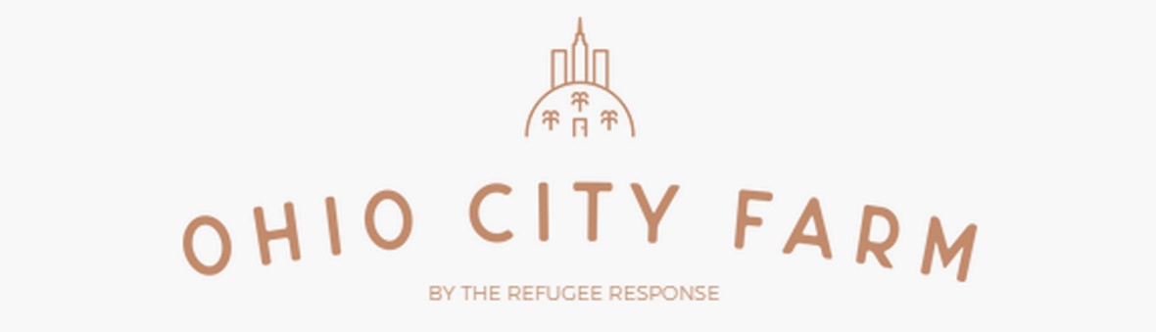

JOIN THE OHIO CITY FARM CSA PROGRAM!
The Ohio City Farm Located at Bridge Ave & W 24th St, is Cleveland’s premier urban farm, offering fresh vegetables and herbs as well as value added items such as raw honey, fresh naan bread, and dried spices all produced on our farm by local refugees using organic methods. One of the best ways to get in on the action is to join the farm’s Community Supported Agriculture program (CSA). The CSA is a weekly opportunity to access in-season produce harvested at its peak quality and thoughtfully packaged each week just for you.
Joining the Ohio City Farm CSA is a great way to support local agriculture and gain access to a weekly share of healthy food. The CSA follows the seasons with each week highlighting delightful produce accompanied by recipe ideas and friendly staff to guide you through the growing season.
2019 Ohio City Farm CSA Details
20 weeks: May 31st - October 11th
Share Options
Half Share- $300 total ($15 per week) Ideal for 1-2 people or families who cook at home less often*
Full Share- $500 total ($25 per week) Ideal for families of 3-7 people or those who cook at home frequently *
*These are estimates based on previous customer input
Pick-up Locations- (you must choose one location when you register but can change pick-up location at any time for your convenience)
Friday Pick-up
- Cleveland Eastside, Gilmour Academy, 2045 SOM Center Road, Gates Mills, Ohio 44040 - Fridays 5:00pm - 6:30pm

Visit our website at
http://www.ohiocityfarm.com
for more details and to purchase your share!

All CSA members receive 20% discount on all refugee response events, including our popular annual REAP the Benefit street festival.

