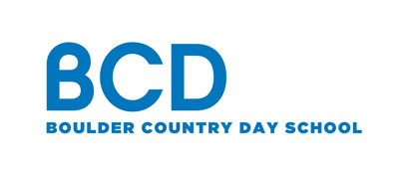 Contact: Boulder Country Day School
FOR IMMEDIATE RELEASE Diana Emerson
303-527-4931 x 295
demerson@bouldercountryday.org
www.bouldercountryday.org

Philip Mayhoffer from Boulder Country Day School selected as one of 110

LEGO® Education Master Educators
LEGO® Welcomes US Educators to the LEGO Education Master Educator Program

Boulder, CO (June 2018) – BCD MS STEM and Programming teacher, Phil Mayhoffer, has been selected to participate in the first cohort of the US LEGO Education Master Educator program. The program which is designed for educators in early learning through secondary school who currently use LEGO hands-on learning solutions in their classroom. The selected participants embody the LEGO Education mission of enabling success for all students through hands-on learning experiences.
The 110 LEGO Education Master Educators will enjoy many activities including access to like-minded educators, insider news of special LEGO Education offers and events and recognition. They will also be invited to provide feedback to LEGO hands-on learning solutions and programs.
“Shining a spotlight on the good work of educators and sharing best practices from classrooms across the country are top priorities for LEGO Education,” said Silver McDonald, head of LEGO Education North America. “It’s why we’re launching the LEGO Education Master Educator program and eagerly awaiting to welcome and start learning from the first cohort of Master Educators.”
Mr. Mayhoffer instructs several after school Lego courses, as well as, coaches a combined Fist Lego League team made up of students from Boulder Country Day School and the I Have a Dream Foundation of Boulder County (IHAD) (link to news story on First Lego League team). "I am super excited about this opportunity," says Mayhoffer. "I expect that my participation in the program will enrich the classes I teach at BCD and our FIRST LEGO League teams."
Official Lego Education press release
###
Boulder Country Day School is a top-rated, accredited private school in Boulder, Colorado where every child has the opportunity to discover his or her own unique excellence. Distinguished by small class sizes, outstanding faculty, rigorous curriculum and a focus on community, our preschool, elementary and IB middle school teachers strive to create a well-rounded educational environment that balances traditional subjects with the arts, world languages, athletics and project-based learning.
About LEGO Education - LEGO Education provides hands-on, playful learning tools that engage every student's natural curiosity, and help them develop the skills and confidence they'll need in the future.
LEGO and the LEGO logo are trademarks and/or copyrights of the LEGO Group. ©2018 The LEGO Group. All rights reserved.

