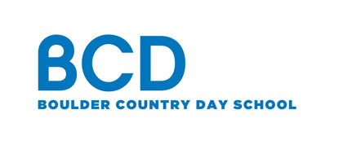 Contact: Boulder Country Day School
FOR IMMEDIATE RELEASE Diana Emerson
303-527-4931 x 295
demerson@bouldercountryday.org
www.bouldercountryday.org

Boulder Country Day School to host public conversation on Identity, Difference and Allyship
Through thoughtful reflection and conversation, we can raise our awareness and challenge stereotypes

Boulder, CO (February 2019) –

February 27th, 2019 from 6:00pm - 7:30pm. Free and open to the public.
Research shows that throughout early childhood, children become aware of cultural identities such as gender, race, ethnicity and ability. They also begin to absorb society’s messages about these forms of identity, which often subtly reinforce stereotypes and bias. How can parents work to actively counter these pervasive messages in order to foster children’s anti-bias development? Boulder Country Day School will hold a public conversation on February 27th from 6:00pm - 7:30pm on Identity, Difference and Allyship.

Through thoughtful reflection and conversation, we can raise our awareness and challenge stereotypes. Led by Randi Reinhold, BCD's Coordinator of Equity & Inclusion, the goal of this workshop will be to provide participants with language and proactive strategies for addressing children’s questions and misconceptions around difference and modeling how to be an ally through action and dialog. Participants will be asked to engage in thoughtful reflection and discussion around personal identity.

RSVPs welcomed at www.bouldercountryday.org

###
Boulder Country Day School is a top-rated, accredited private school in Boulder, Colorado where every child has the opportunity to discover his or her own unique excellence. Distinguished by small class sizes, outstanding faculty, rigorous curriculum and a focus on community, our preschool, elementary and IB middle school teachers strive to create a well-rounded educational environment that balances traditional subjects with the arts, world languages, athletics and project-based learning.

